EXPT NO: 4 | TRANSFER LEARNING USING PRE-TRAINED VISION MODELS FOR IMAGE RECOGNITION
DATE:

PRE-LAB QUESTIONS (PROVIDE BRIEF ANSWERS TO THE FOLLOWING QUESTIONS)

- What is transfer learning in deep learning?

Transfer learning is a technique where a model trained on a large dataset is reused for a new but related task. Instead of training the entire model from the beginning, the knowledge learned by the pre-trained model is transferred to the new task. This saves time and computational resources.

- What are the advantages of using pre-trained models over training from scratch?

- Requires less training time and computational power.
- Works well even with small datasets.
- Usually provides better accuracy.
- Reduces the amount of data required.
- Allows reuse of features learned from large datasets.

- What is the role of fine-tuning in transfer learning?

Fine-tuning means slightly retraining a pre-trained model using the new dataset. Usually, some early layers are kept frozen while later layers are trained or adjusted. This helps the model adapt its learned features to the specific new task.

- Name any three popular pre-trained computer vision models.

Three popular pre-trained computer vision models are:
VGG16
ResNet50
InceptionV3
Other examples include MobileNet, EfficientNet, and DenseNet.

- What is the purpose of Hugging Face and how is it useful in deep learning?

Hugging Face is a platform and open-source ecosystem that provides pre-trained models, datasets, and tools for deep learning. It is widely used for NLP, computer vision, audio, and multimodal AI. Developers can easily download, use, fine-tune, and share models through its Transformers library and Model Hub.

AIM
To implement transfer learning using pre-trained vision models for image recognition and evaluate their performance on real-world image datasets.

SOFTWARE REQUIREMENTS
- Python
- TensorFlow/Keras or PyTorch
- Google Colab
- Hugging Face Transformers
- Kaggle Dataset
- Matplotlib
- GitHub

OBJECTIVES
Students will be able to:
- Understand the concept of transfer learning.
- Apply pre-trained vision models for image recognition.
- Fine-tune models such as ResNet or AlexNet.
- Utilize Kaggle datasets and Hugging Face vision models.
- Compare transfer learning performance with custom CNN models.

PROCEDURE
PART A: DATASET PREPARATION
Perform the following tasks:
- Download an image dataset from Kaggle.
- Load and preprocess the images.
- Split the dataset into training, validation, and testing sets.

PART B: IMPLEMENTING TRANSFER LEARNING
Load a pre-trained model such as:
- ResNet-50
- AlexNet
Replace the final classification layer according to the dataset classes.
Freeze the feature extraction layers.
Compile the model.

PART C: MODEL TRAINING AND PERFORMANCE EVALUATION
Train the transfer learning model.
Record:
- Training accuracy
- Validation accuracy
- Training loss
- Validation loss
- Test accuracy
Visualize:
- Accuracy vs Epoch
- Loss vs Epoch

PART D: USING HUGGING FACE PRE-TRAINED MODELS
Perform the following tasks:
- Load a pre-trained vision model from Hugging Face.
- Perform image classification on sample images.
- Compare predictions with the transfer learning model.
- Document observations and upload the notebook to GitHub.

(CODE: CONATAINS STUDENT ROLL NOS
SCREENSHOT OF CODE
SCREENSHOT OF OUTPUT)

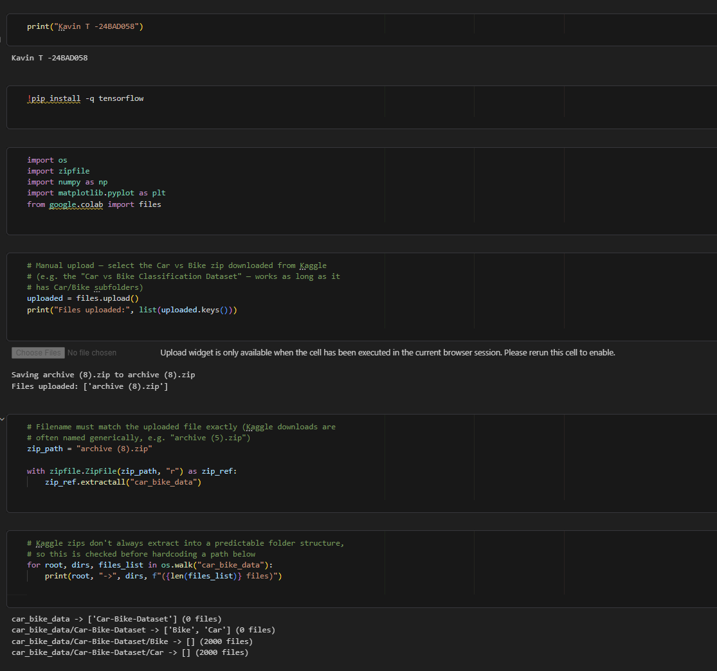

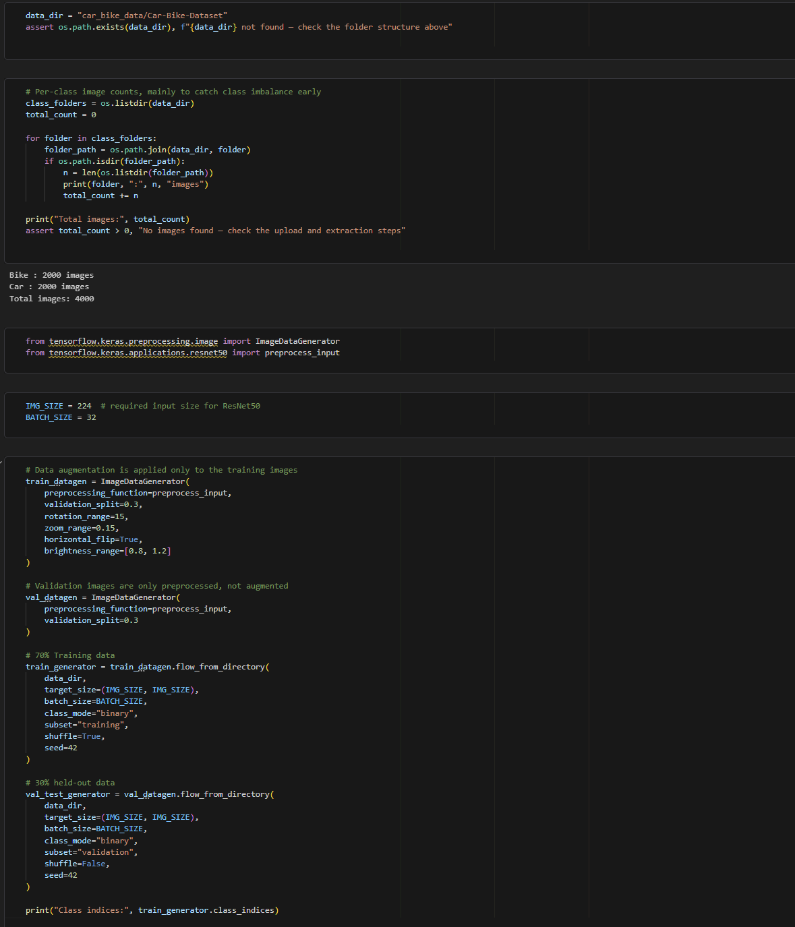

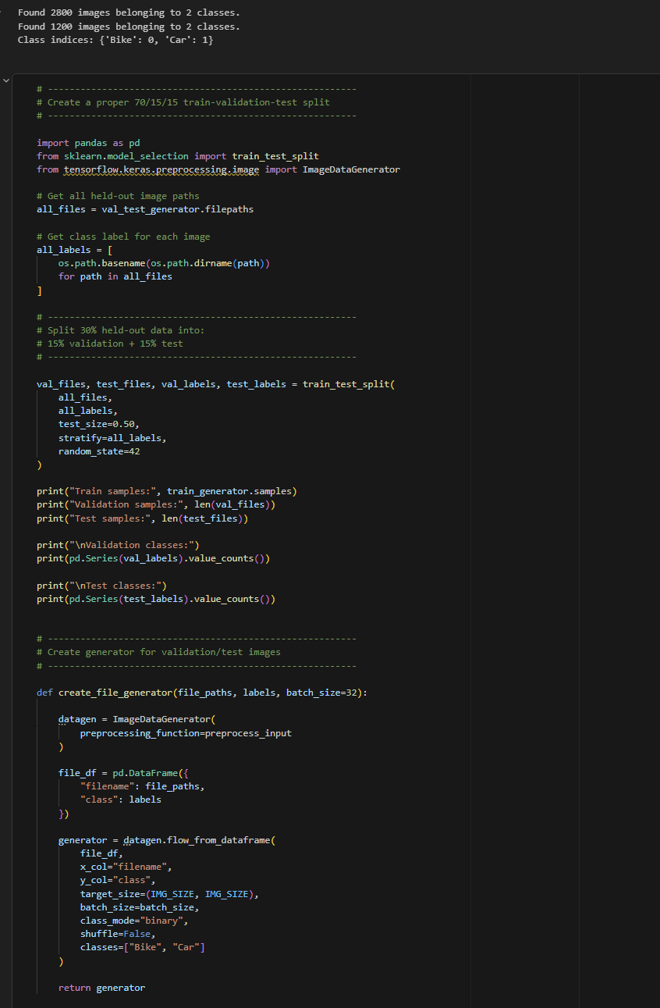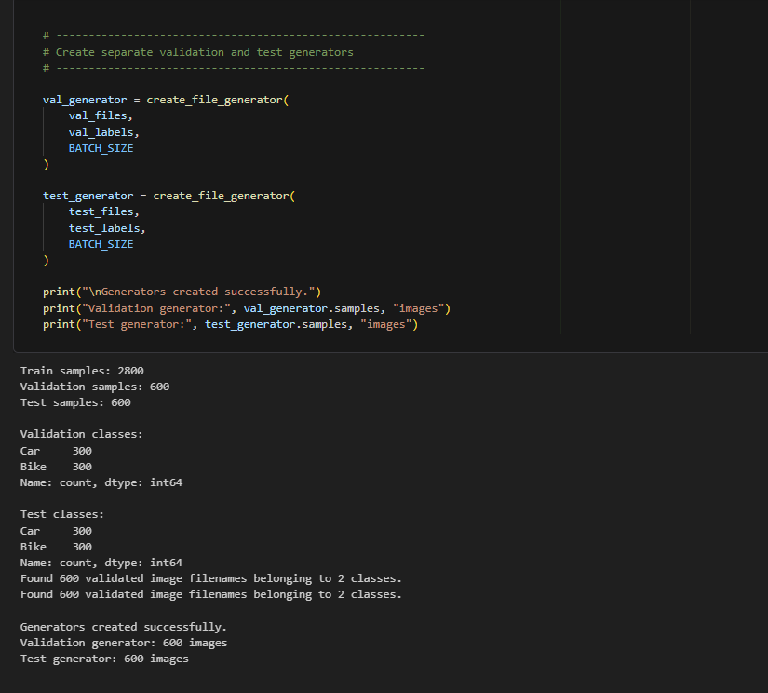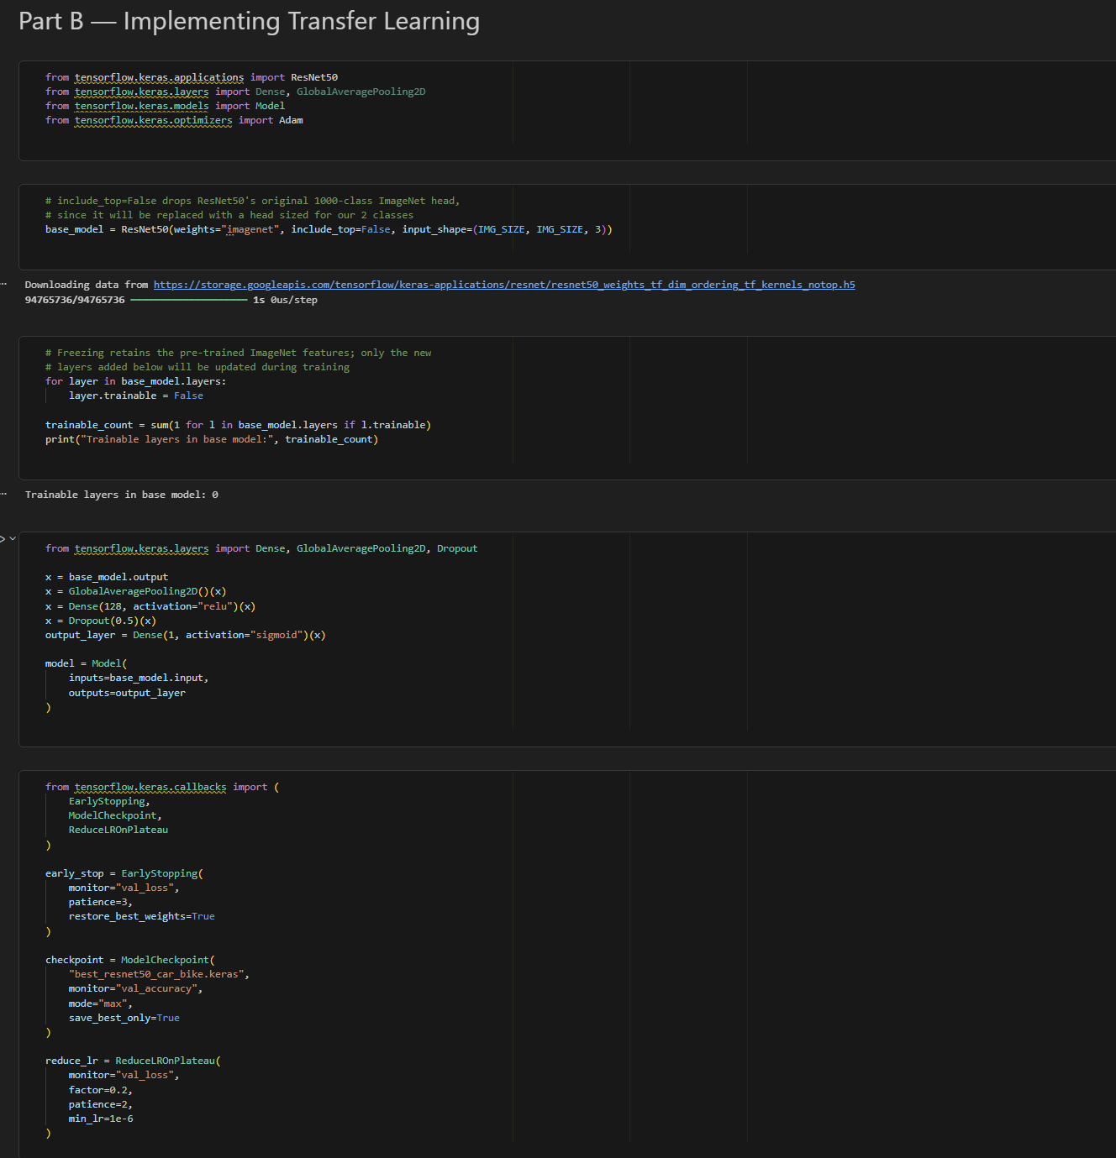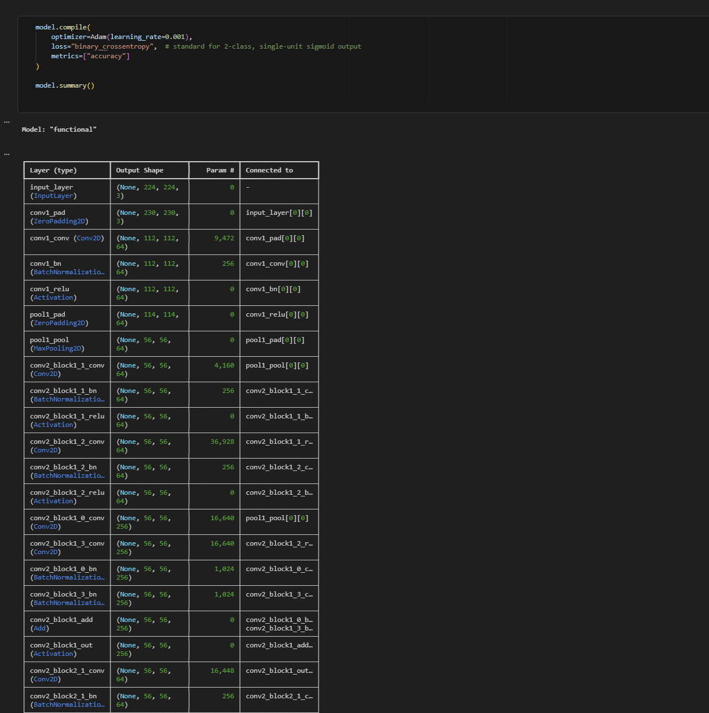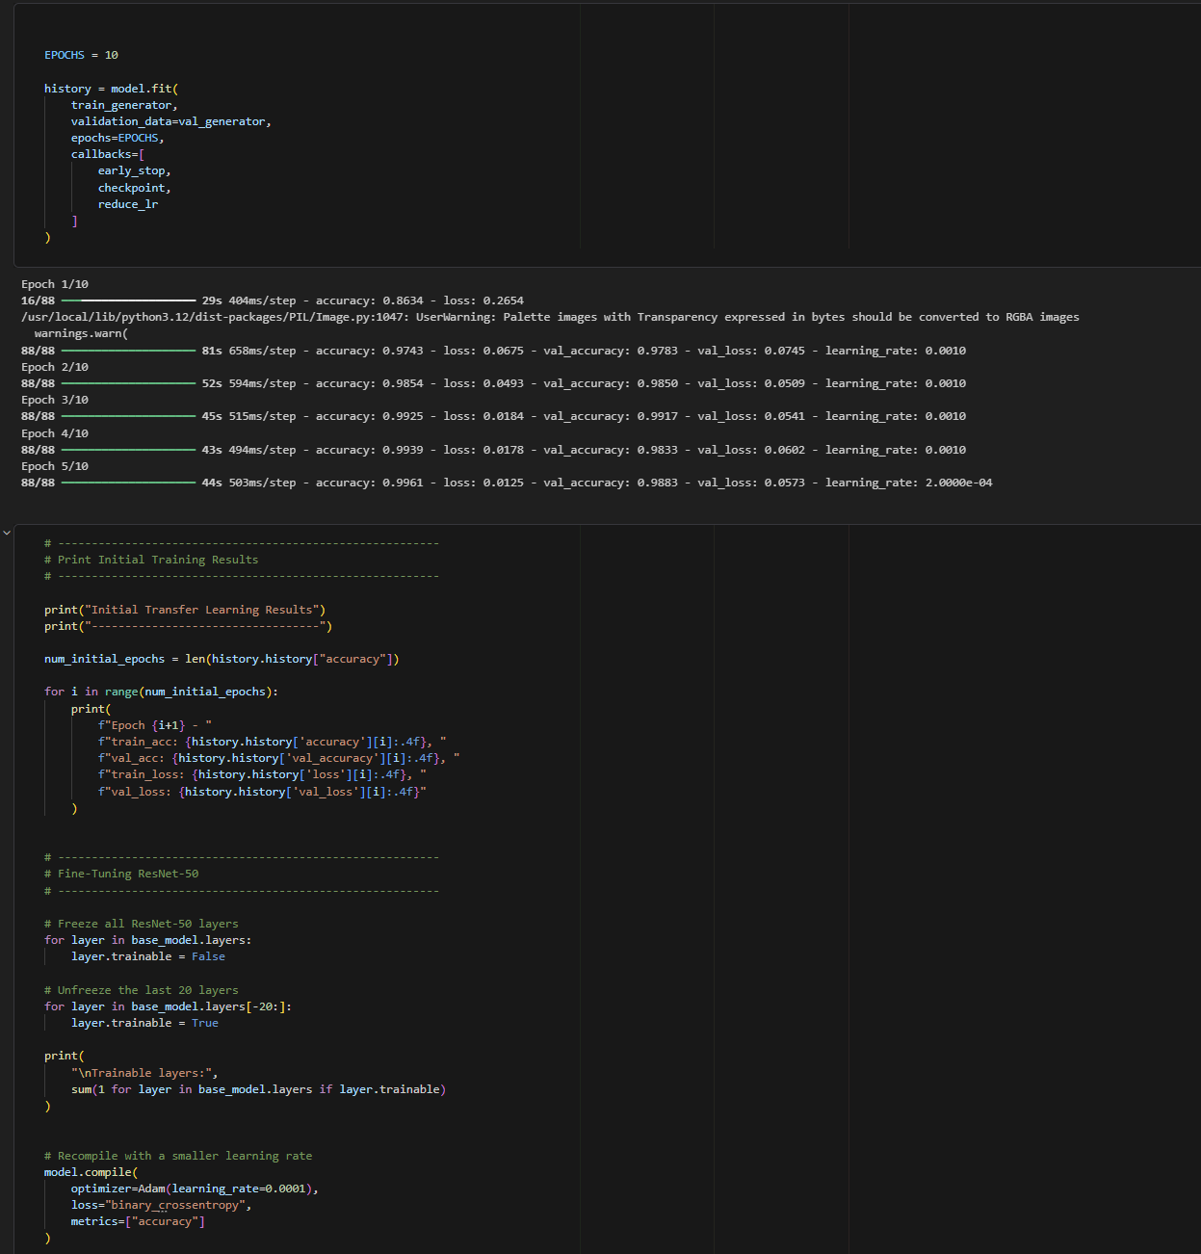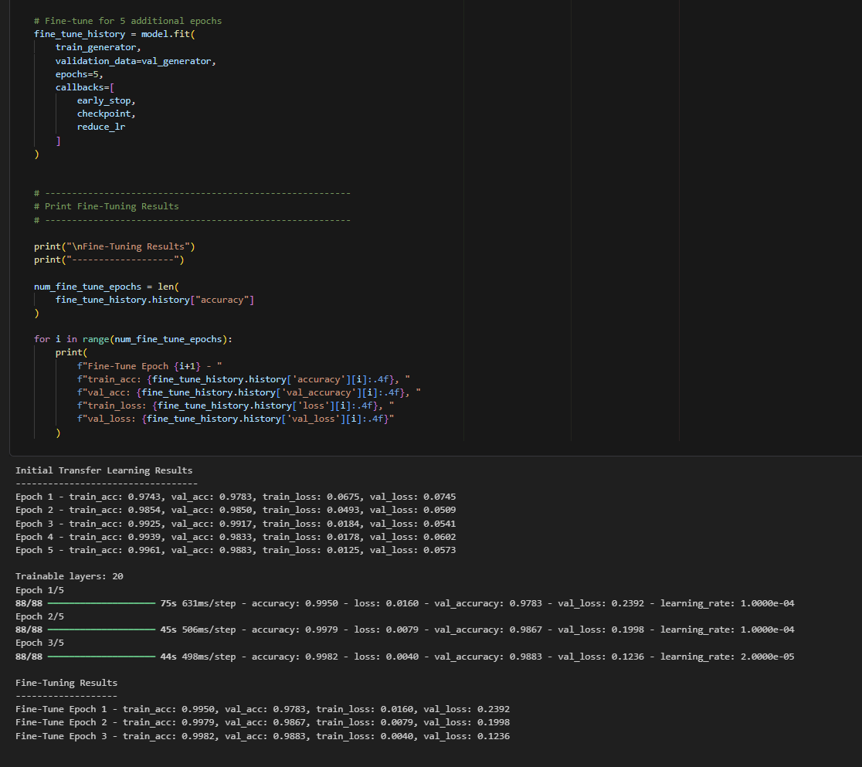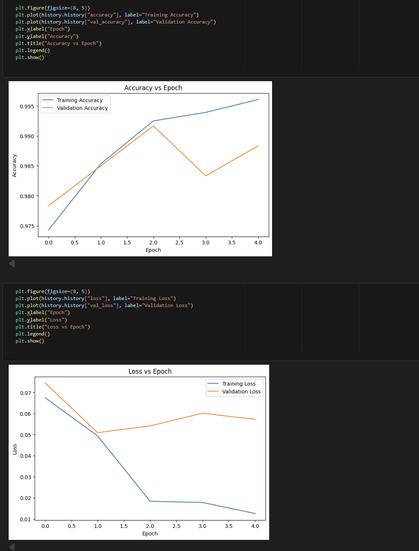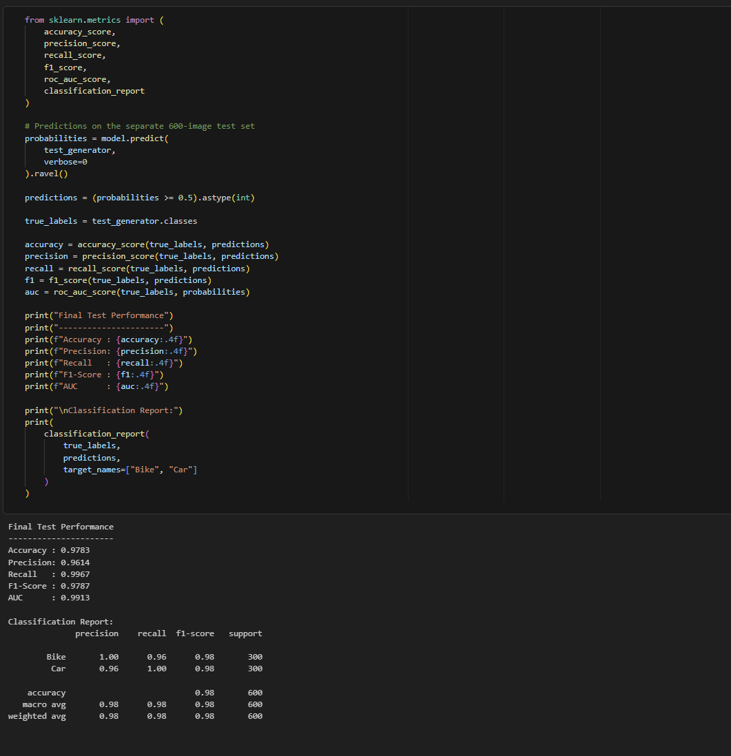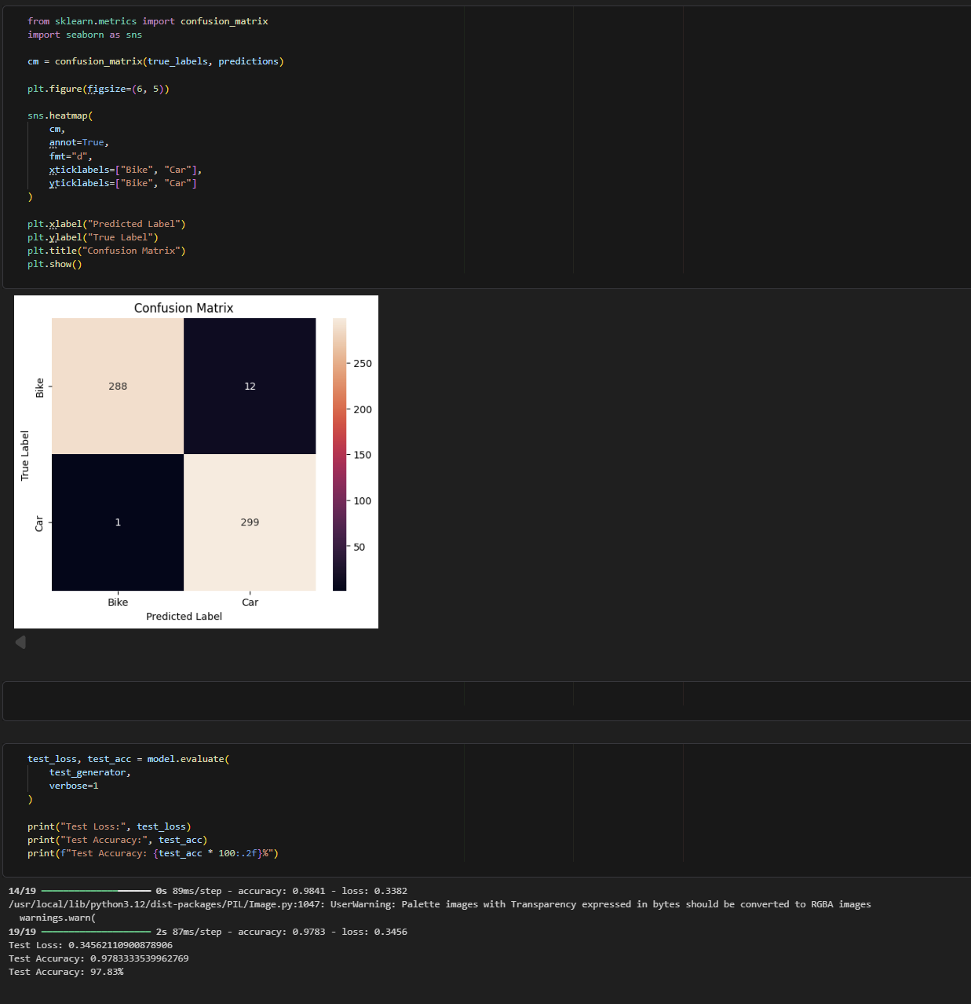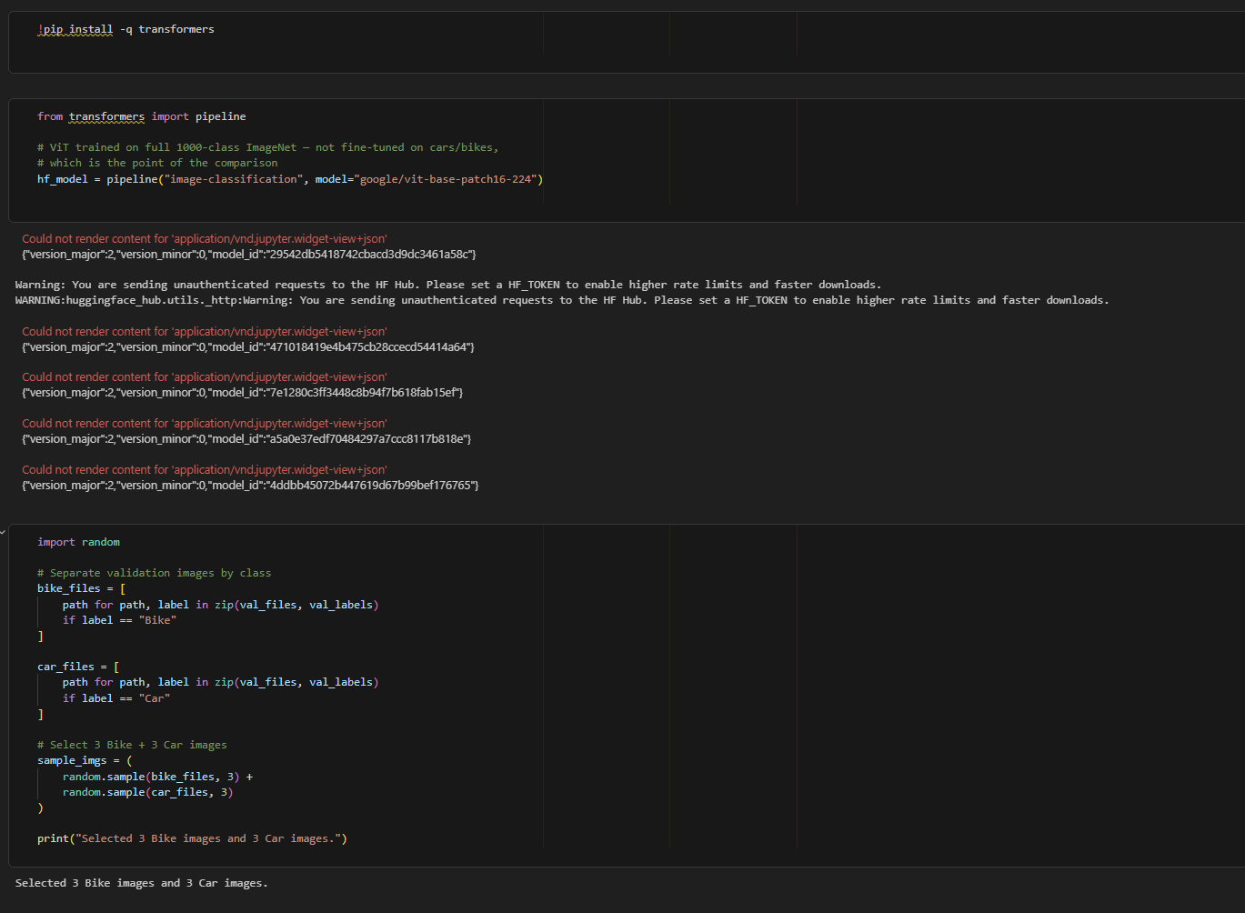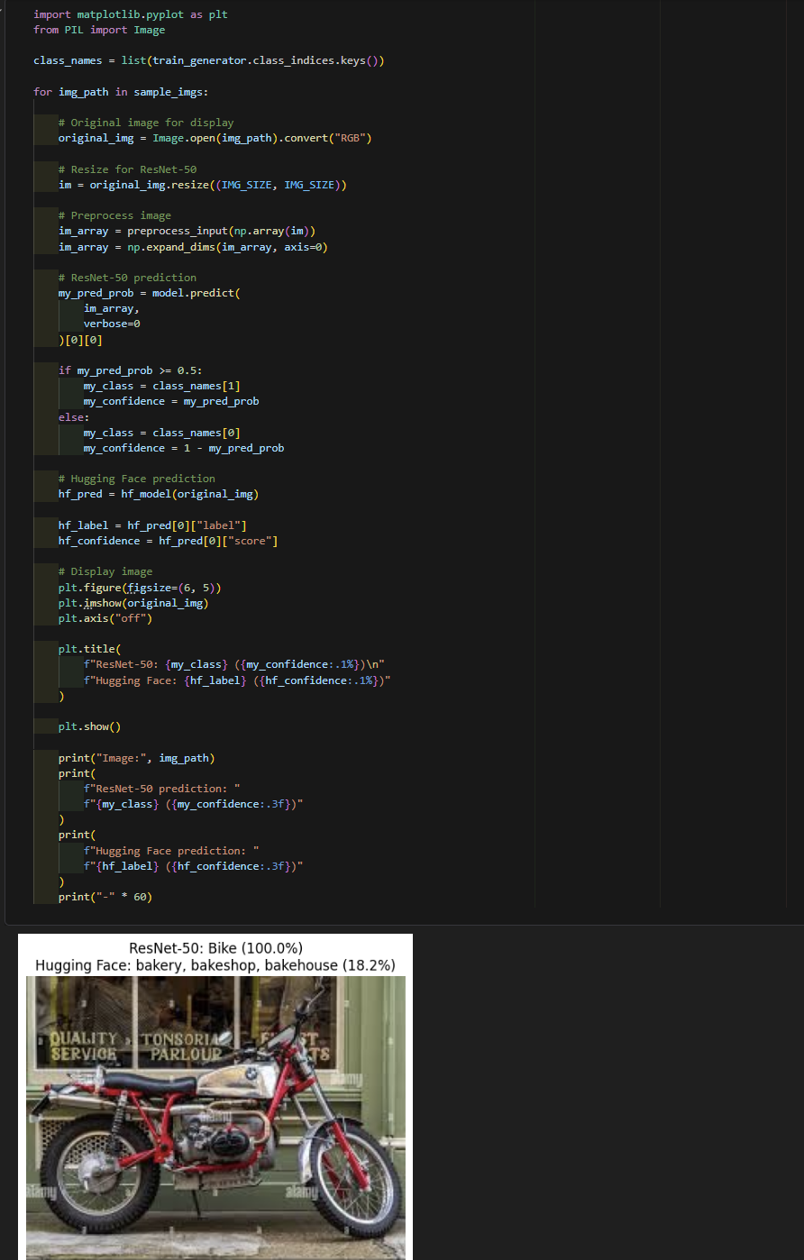

EXPECTED OUTCOME
Students will understand the advantages of transfer learning and gain practical experience in fine-tuning pre-trained vision models from TensorFlow/PyTorch and Hugging Face for image recognition tasks.

POST-LAB QUESTIONS (PROVIDE BRIEF ANSWERS TO THE FOLLOWING QUESTIONS)

- What are the advantages of transfer learning compared to training a CNN from scratch?

Transfer learning uses a model that has already learned useful features from a large dataset. It requires less training time, less data, and fewer computational resources than training a CNN from scratch. It also generally provides better accuracy, especially when the new dataset is small.

- Why are pre-trained models able to achieve higher accuracy with fewer training epochs?

Pre-trained models have already learned important features such as edges, textures, shapes, and patterns from large datasets. Therefore, they do not need to learn these basic features again. Only the task-specific features need to be adapted, allowing the model to achieve good accuracy in fewer epochs.

- Compare the performance of the transfer learning model with the CNN implemented in the previous experiment.

The transfer learning model generally performs better than a CNN trained from scratch. It usually reaches higher validation/test accuracy faster and has lower training requirements. The CNN from scratch needs more epochs and data to learn useful features, while transfer learning starts with already learned features.

- What is the purpose of freezing layers during transfer learning?

Freezing layers prevents their weights from being updated during training. The pre-trained layers retain the useful features they have already learned, while only the new or selected layers are trained for the new task. This reduces training time, computational cost, and the risk of overfitting.

- How can Hugging Face simplify the deployment and experimentation of vision models?

Hugging Face provides a large Model Hub containing pre-trained vision models, datasets, and ready-to-use libraries. Users can quickly download and test different models without implementing them from scratch. It also provides tools for fine-tuning, evaluation, sharing, and deployment, making experimentation with computer vision models easier.

ASSESSMENT
Description | Max Marks | Marks Awarded
Pre Lab Exercise | 5
In Lab Exercise | 10
Post Lab Exercise | 5
Viva | 10
Total | 30
Faculty Signature

